**HEART BEAT DETECTOR USING ARDUINO**

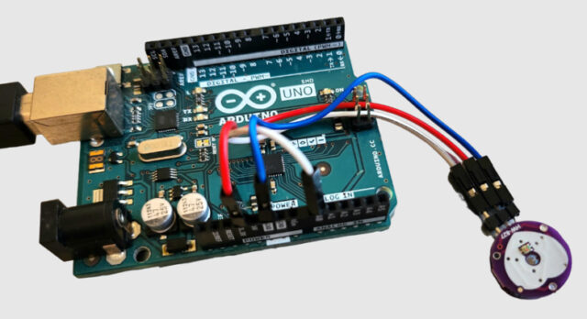

**Components/Hardware Required**

We need following components for this project. All the components can be purchased from the given links.

| **S.N.** | **Components** | **Quantity** |
| --- | --- | --- |
| 1 | Arduino UNO Board | 1 |
| 2 | Pulse Sensor | 1 |
| 3 | 16X2 I2C LCD Display | 1 |
| 4 | Jumper Wires | 10 |
| 5 | Breadboard | 1 |
|  |  |  |

### ****Pulse Sensor****

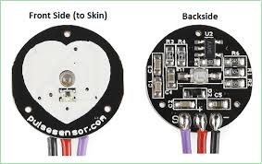

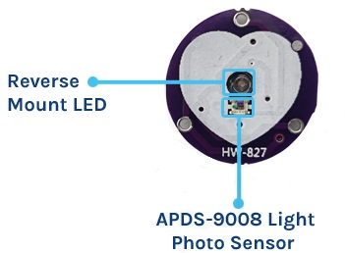

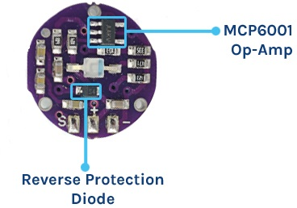

#### **Working of the Pulse Sensor**

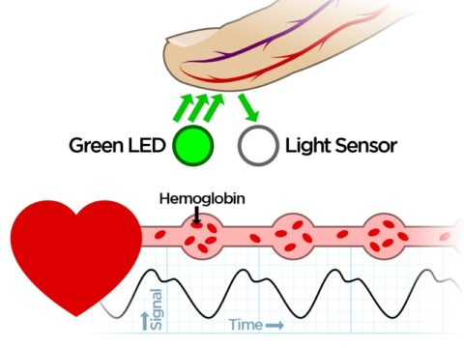

#### **Pulse Sensor PinOut**

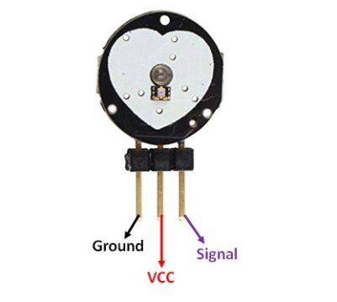

### ****Interfacing Pulse Sensor with Arduino****

